**Lab 5: *Hashes, Asymmetric Encryption & Digital Signatures* (2%)**

**Name: Khai Phan Student Number: 100901164**

**Results**

**Part 1: Capturing a secure SSH Connection**

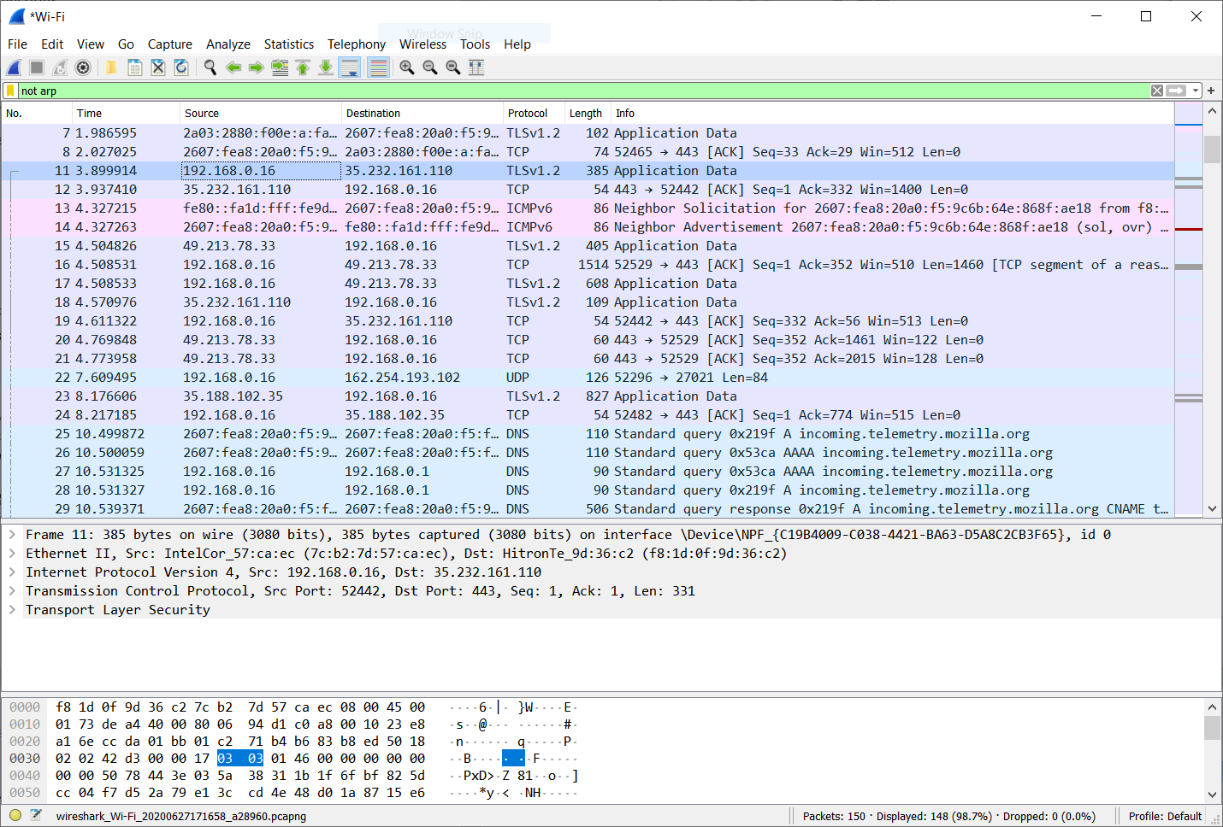

*Image 1: This is the transfer handshake between my IP address and the server IP address*

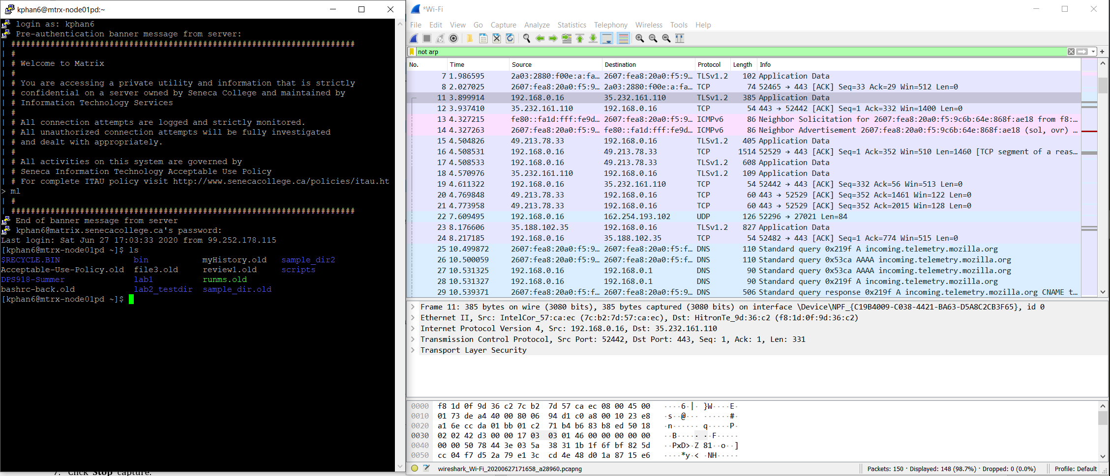

*Image 2: This is my handshake connection with the SSH windows which I just di a list command (ls)*

**Part 2: Capturing a TLS Transmission**

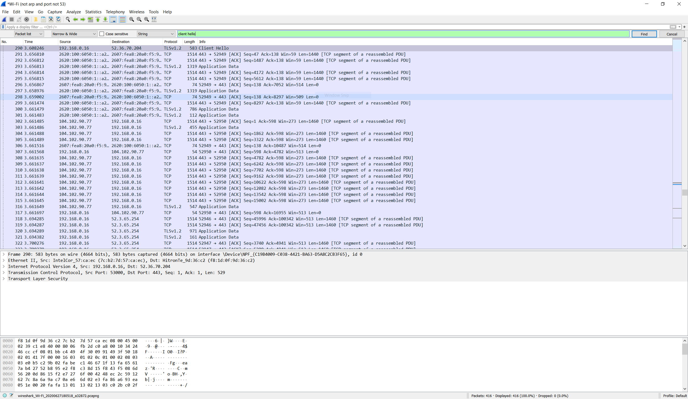

*Image 3: Client acknowledge and prompt “Hello” to establish connection with the server*

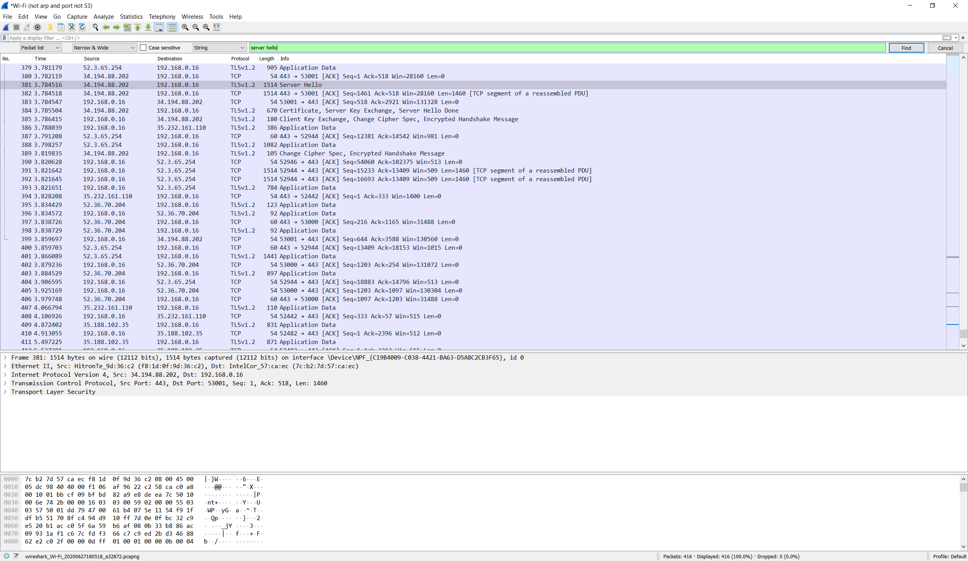

*Image 4: Server acknowledge the prompt from Client and authenticate user, prompt “Hello” back to user if authentication step is success*

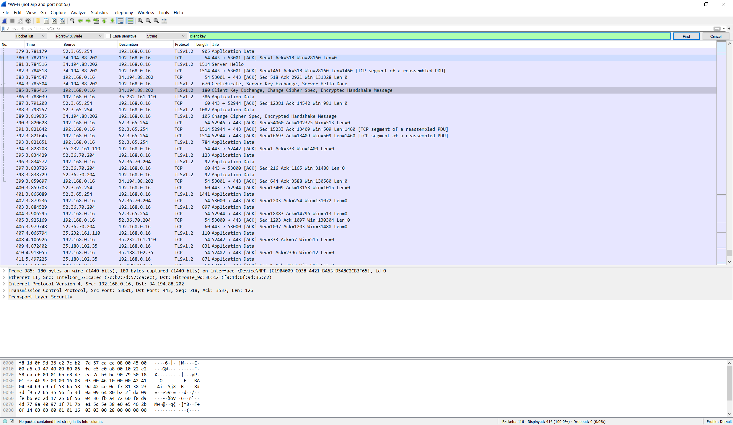

*Image 5: Client Key Exchange*